PIZZA SALES SQL QUERIES
- KPI’S:
- Total Revenue
Output: SELECT sum(total_price)
AS `total revenue` FROM pizza_sales;
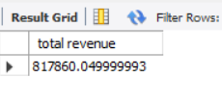

- Average Order Values
Output: SELECT sum(total_price) / count(DISTINCT order_id) AS `avg order values` FROM pizza_sales;
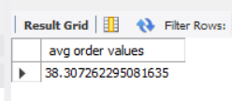
- Total Pizza Sold
Output: SELECT sum(quantity) AS `Total Pizza Sold` FROM pizza_sales;
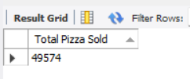
- Total Orders
Output: SELECT count(DISTINCT order_id) AS `Total Orders` FROM pizza_sales;
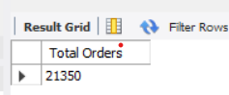

5. Average Pizzas Per Orders
Output: SELECT sum(quantity) / count(DISTINCT order_id) AS `avg pizza per order` FROM pizza_sales;

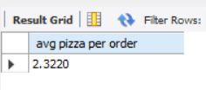

B. DAILY SALES TREND
Output: SELECT DAYNAME(STR_TO_DATE(order_date, '%d-%m-%Y')) AS order_day,
COUNT (DISTINCT order_id) AS total_orders FROM pizza_sales
GROUP BY DAYNAME(STR_TO_DATE (order_date, '%d-%m-%Y'));

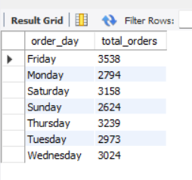

C. MONTHLY SALES TREND
Output : SELECT MONTHNAME(STR_TO_DATE(order_date, '%d-%m-%y')) AS `month` , COUNT(DISTINCT order_id) AS `total orders` FROM pizza_sales
GROUP BY MONTHNAME(STR_TO_DATE(order_date, '%d-%m-%y'))
order by `total orders` desc;
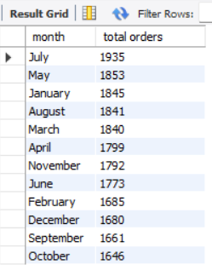

D. PERCENTAGE OF SALES BY PIZZA CATEGORY.
Output: SELECT pizza_category, sum(total_price)*100 / (select sum(total_price) from pizza_sales) as `PCT`
from pizza_sales
group by pizza_category;
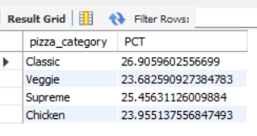

E. PERCENTAGE OF SALES BY PIZZA SIZE
Output: select pizza_size, cast(sum(total_price)*100 / (select sum(total_price) from pizza_sales) as decimal(10,2)) as `PCT`
from pizza_sales
group by pizza_size
order by `pct` desc;

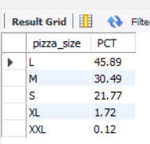

F. Total Pizzas Sold by Pizza Category
Output: select pizza_category, sum(quantity) as `total quantity`
from pizza_sales
group by pizza_category
order by `total quantity` desc;
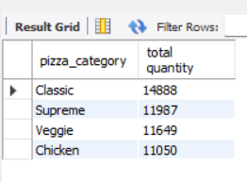

G. Top 5 Pizzas by Revenue
Output: select pizza_name , sum(total_price) as `total revenue`
from pizza_sales
group by pizza_name
order by `total revenue` desc limit 5;
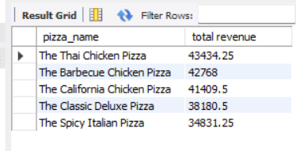

H. Bottom 5 Pizzas by Revenue
Output: select pizza_name, sum(total_price) as `total revenue`
from pizza_sales
group by pizza_name
order by `total revenue` asc limit 5;
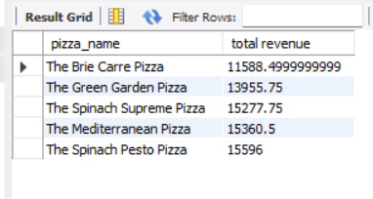

I. Top 5 Pizzas by Quantity
Output: select pizza_name , sum(quantity) as `total quantity`
from pizza_sales
group by pizza_name
order by `total quantity` desc limit 5;
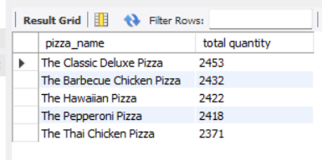

J. Bottom 5 Pizzas by Quantity
Output: select pizza_name, sum(quantity) as `total quantity`
from pizza_sales
group by pizza_name
order by `total quantity` limit 5;

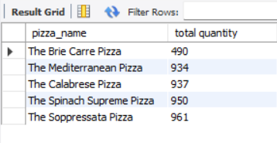

K. Top 5 Pizzas by Total Orders
Output: select pizza_name, count(distinct order_id) as `total orders`
from pizza_sales
group by pizza_name
order by `total orders` desc limit 5;

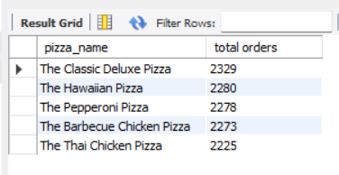

L. Bottom 5 Pizzas by Total Orders
Output: select pizza_name, count(distinct order_id) as `total orders`
from pizza_sales
group by pizza_name
order by `total orders` asc limit 5;

